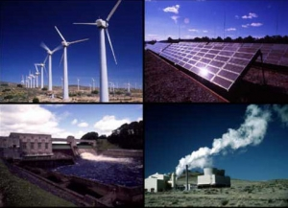
Alternative Energy
Outline: Fossil fuel energy makes up 75% of the energy usage in Canada today. One of the byproducts of combustible energy sources is CO₂ (carbon dioxide) which is a known contributor to the greenhouse effect. Humanity cannot continue to rely on fossil fuels for the majority of our energy usage, but there are alternatives!
Project: You are going to write a brief 500 word essay about a type of energy that you think is the best!
Research and write about a type of alternative energy that you think could be the new energy source for our planet. You can use chapter 11.3 in your text book as a starting point, but there are many other exotic energy sources around, and I would be very excited to hear about something I haven’t heard of before! CHECK IT OUT!
You will work on this by yourself, researching online and in the library. Make sure you keep track of all your references, and use the reference guidelines on my website.
Discuss 1) how your energy works 2) why it’s the best and 3) any draw backs that this energy source has, and why it’s not implemented everywhere already
Due: The report will be due on the 7th/8th of February.
Marks: The report will be out of 15 marks total – with 10 marks for research and information and 3 marks for your writing ability and 2 marks for your bibliography (check my website)
How to succeed: ** Do not copy and paste information off of the internet**
- Use sources from the library and internet to add to your understanding of your topic
- Translate your understanding into your own words and type them out; use a computer, do not hand write your information
- Chose an idea that you are passionate about and that you think has the potential to change our world, and replace combustible energy sources.
- Finish 90% of your project AT LEAST 1 week before you present, and use the last week to perfect your presentation, and make it look fabulous!
- Remember projects are worth a lot of your mark, so put in a good effort
Good luck! - Mo

